Annual Progress Report

United Nations Development Programme
Tunisia
Green Economy: Women’s Economic Empowerment in Tunisia
01/01/2023 – 31/12/2023

Reporting Period | 01/01/2023 – 31/12/2023
Donor | Canada
Country | Tunisia
Project Title | Green Economy: Women’s Economic Empowerment in Tunisia (GEWEET)
Project ID  (Atlas Award ID)  Outputs  (Atlas Project ID and Description)  Strategic Plan and/or CPD Outcomes | 00120306  #1. In 2025, institutions are leading effective, risk-informed public policies in partnership with economic and social actors, putting the resources of the country at the service of an inclusive, sustainable and resilient socio-economic development that generates decent jobs, especially for the most vulnerable.  #3. In 2025, all committed actors will ensure an equitable, transparent, and sustainable management of natural resources, ecosystems, and territories by improving their resilience/adaptation as well as that of populations, notably the most vulnerable in the face of climate risks.
Implementing Partner(s) | Ministry of Economy and Planning (lead)
Project Start Date | January 2022
Project End Date | December 2026
2023 Annual Work Plan Budget | USD 1’742’146
Total resources required | USD 11’862’046
Revenue received | - Regular 207’000 USD  - Other  - Donor 2 957 504.03 USD  - Trust Fund Cost Sharing USD  - Thematic Trust Fund C/S USD  - Special Activities USD  - EU funding USD  - Total USD
Unfunded budget | 6’184’836 USD
UNDP Contact Person | Celine Moyroud  Resident Representative  UNDP Tunisia  Email : celine.moyroud@undp.org
Table of Content

I. Executive summary 3
II. Background 3
III. Progress Review 4
IV. Project Risks and Issues 10
V. Lessons Learned 11
VI. Conclusions and Way Forward 12
VII. Financial Status 14

Executive summary
The "Green Economy: Women’s Economic Empowerment in Tunisia" project, which aims at enhancing the capacities of national and local institutions and women to contribute to the transition towards a green, sustainable, and inclusive economy, has made significant strides during 2023, despite some delays.

Following consultations with national and international partners in 2022, the project was formally endorsed and initiated in March 2023, marking a significant milestone. The steering committee's feedback in March helped shape project phases and clarified the scope and objectives of specific initiatives, ensuring alignment with the national context. The importance of engaging all key partners from the project's pre-launch phase was reaffirmed. Their involvement in defining objectives and tasks enhanced ownership and commitment. Continuous communication helped align diverse stakeholder interests. It was also agreed that robust engagement with partners through a technical committee and participatory approach would ensure better coordination and progress toward project goals.

Another significant achievement in 2023 was the initiation of two comprehensive studies in close collaboration with the Ministry of Environment on the EU's Carbon Border Adjustment Mechanism (CBAM) and elaborating a carbon-neutral strategy for the Gabes region by 2050. These studies will support Tunisia’s shift towards a decarbonized economy that aligns with environmental standards and the country’s commitments, as presented in the National Determined Contribution (NDC).

Additionally, building on this close collaboration with national partners, the project initiated roundtable discussions, which provided a space for various stakeholders to raise issues, solutions, and recommendations, notable on social and solidarity economic, public-private partnership and dialogue in favor of national sustainable development, including its financing, and financial inclusion of the most marginalized populations. The outcome of these discussions was intended to direct activities in 2024.

Beyond engagement of national and regional partners, the Country Office (CO) focused on groundwork for extensive future implementation, as planned in the acceleration plan elaborated in mid-2023. One strategy included merging activities to reduce processes and ensure an efficient start. Consequently, in Q3, applications were launched for four crucial procedures, including to provide technical and material support to women green entrepreneurs, targeting over 600 women for financial services and resilience entrepreneurship training.

2023 thus served as a pivotal year in terms of groundwork and planning for the implementation of activities across outcomes 1 and 2 in 2024 with the objectives that state and non-state actors, including the private sector, at national and local levels, create an enabling environment for inclusive economic development that is resilient to climate change (outcome 1) and that women and vulnerable populations have access to and use financing mechanisms and tools to ensure livelihoods that are resilient to climate change (outcome 2).

Background
Successive shocks (COVID-19, the Ukraine war and rising inflation) have presented Tunisia with new challenges requiring green, inclusive, and sustainable economic recovery and development. The consequences of such shocks have had and can have repercussions on an economy already struggling to deliver equitable and job generating growth. . Vulnerable populations, including young people and women, have been significantly impacted. The unemployment rate for women serves as evidence of the marginalization of this group from economic activities. In the first quarter of 2023, men’s unemployment rate was 13.9 % while women's unemployment rate stood at 21.2%, (higher than the overall average unemployment rate of 16.1%).

Furthermore, considering the disproportionate impact of climate change on women, and the environmental stresses Tunisia is confronted with, it is crucial to move forward with a greener economy and entrepreneurship.

Tunisia has already committed to decarbonizing and greening its economy. In response to the Paris Agreement, it has increased its Nationally Determined Contribution (NDC) ambition to reduce the economy's carbon intensity by 45 % in 2030. Focusing on the energy sector, which represents 72 % of the greenhouse gas (GHG) reduction potential, is essential to achieve this result. In addition to national strategies and plans, regional strategies must be developed to guarantee the realization of the NDC objectives, especially in regions which emit a considerable amount of GHG and are at an environmental risk, such as Gabes.

As such, the project aims to accelerate the transition to a greener economy in Tunisia, focusing on 7 governorates in central and southern Tunisia: Gabes, Medenine, Kairouan, Tataouine, Kebili, Gafsa and Tozeur. The project aims to achieve its goal by enhancing the capacities of national and local institutions, engaging the private sector, and fostering greener and more inclusive local economic development, particularly benefiting women entrepreneurs.

Progress Review
After a series of consultations in 2022 and contextual adjustment, the steering committee convened in March 2023 to formally endorse the project, sign the project document, and initiate its implementation. The feedback raised during the steering committee meeting was collected and factored into the project phases, particularly drafting the missions’ terms of reference to best align project objectives with the national context.

Although the project did not start to deliver tangible results in 2023, the Country Office laid the groundwork for an acceleration plan for implementation to ensure an efficient start. As such, the CO launched calls for applications during Q3 2023 for four critical processes. These missions aim at providing the national and local institutions with the skills to design and implement inclusive and carbon neutral public policies as well as the tools to finance this transition to a greener economy and the achievement of the Sustainable Development Goals (SDGs). In addition, work was also initiated to offer women entrepreneurs the knowledge, tools, and mechanisms that will support resilient and sustainable economic empowerment. As such, the process related to elaborating a carbon-neutral strategy for the Gabes region by 2050 was launched and finalized at the end of 2023 (Output 1.1). One process was related to technical and material support for women green entrepreneurs, whereby over 300 women will be trained on financial services and creating or developing resilient enterprises, and over 300 women will be supported and coached with 21 economic projects materially supported) (related to Output 2.3) ; another process concerned elaborating a report on innovating financing mechanisms for the SDGs and recommendations for their development and operationalization (related to Output 1.3). One process combined two activities aiming to support national institutions in integrating more green economy concepts in public policies while remaining gender sensitive. It also aims to support public regional institutions supporting entrepreneurs in elaborating environmentally sensitive curriculums to support the diffusion of green entrepreneurship (related to output 1.1 and 1.2).

Building on support to the Ministry of Environment regarding the European Union’s Carbon Border Adjustment Mechanism (CBAM), UNDP started to elaborate a comprehensive study on several aspects of the CBAM's impact on Tunisian enterprises (related to output 1.1). Its objectives are to identify the Tunisian companies affected by the CBAM, to estimate the GHG emissions linked to exportations of Tunisian goods covered by the CBAM and the financial adjustment that will be applied in 2026 to Tunisian CBAM-covered goods. Finally, the study will provide a roadmap until 2030 to support the shift to a decarbonized economy aligned with these environmental standards to help Tunisia remain competitive within the context of climate change and the international paradigm shift.

Moreover, to ensure ownership by the national partners, activities were planned in close collaboration with them. UNDP initiated the work on evaluating the macroeconomic impact of carbon neutrality and elaborating a carbon-neutral strategy by 2050 at the regional level in the Gabes governorate, which is widely affected by climate change (as part of Output 1.1). This mission began with a strong commitment from national partners and effective coordination, particularly with the Ministry of Environment, leading the mission efforts and facilitating collaboration with key national partners, including the Ministry of Interior, which is primarily responsible for local and regional affairs, along with other crucial ministries and decentralized institutions, such as governorates and regional development departments (decentralized directions of the Ministry of Economy and Planning). These discussions helped set the approach, methodology, and stakeholders involved and define the content of the terms of references.

UNDP also organized a series of four round tables to inform the project’s initiatives supporting institutions for the legislative and institutional framework related to social and solidarity economy and green entrepreneurship (output 1.1), aiming at developing new and alternative financing mechanisms (output 1.3) and the public-private dialogue in favour of local, sustainable and inclusive development, as well as strengthening financial inclusion of vulnerable populations.
Between October and December in Tunis, the round tables gathered on average over 25 actors from the public, private and banking sectors or civil society and experts. The events provided an open and honest space to raise issues, solutions, and recommendations on several topics. Beyond the diagnostic, what came out of these round tables was many recommendations, collected and documented, that will serve in specific activities for 2024 and later years.

The first roundtable (October 2023) examined how to strengthen the framework to enable the social and solidarity economy to fully develop and reach its potential as a resilient, inclusive and sustainable economic model. In addition to harmonizing and consolidating the SEE approach and concept between the different institutional key actors, it was recommended that a communication and advocacy strategy be implemented in favour of a social and cultural environment conducive to SEE. Finally, the stakeholders insisted on facilitating the financing of SSE structures (for instance, through the creation of cooperatives or adapted insurance solutions).
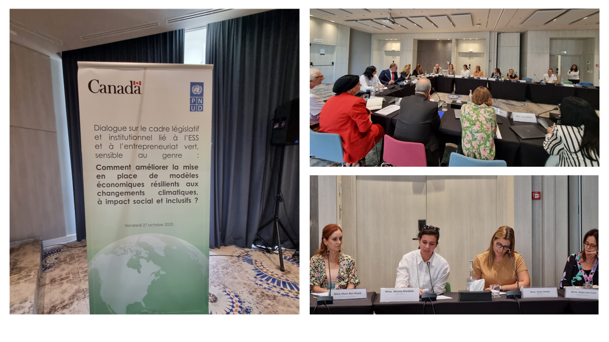
Roundtable “How to improve the implementation of economic models resilient to climate change, with social impact and inclusive?” (27/10/2023)

The second and fourth roundtables (November and December) focused on financing development, examining public-private partnerships, the private sector’s involvement, and alternative financing mechanisms. Although separate, the two roundtables completed each other. A few recommendations emerged: better align resources with the impact objectives by identifying the socio-economic and environmental needs in which the private sector can invest and to facilitate alternative or green finance through various means. It included implementing specific mechanisms (such as a carbon credit), encouraging green and sustainable accounting of the economic actors, and adopting interoperable payment solutions, among others. The discussion also highlighted the importance of elaborating an integrated national investment strategy (driven by the State) to develop coherent sectoral strategies.

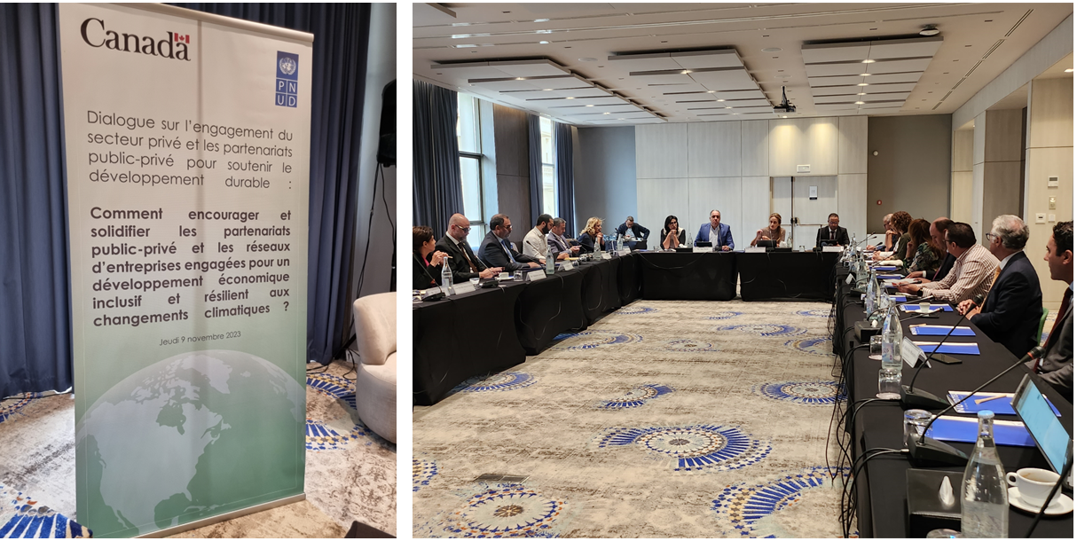

Roundtable “How to encourage and strengthen public-private partnerships and networks of committed enterprises in favour of an inclusive, resilient to climate change economic development ?” (09/11/2023)

The third roundtable (November) dealt with financial inclusion. To address the issues and obstacles women and vulnerable populations met, the stakeholders suggested improving digital inclusion, not only by digitalizing public services and payment modalities but also by simplifying the offers. An overall recommendation was to improve financial education. The measures proposed were establishing a coordinated and concerted strategy for financial education and shifting behaviours and beliefs to build trust between the people and financial institutions. The stakeholders emphasized the importance of better coordination and collaboration between all key actors, partly built on updated and comprehensive data on financial inclusion.

Below is a table summarizing the progress aligned with the work plan.

Outcome… | Output | Activity | Status (as of 31/12/2023)
Outcome 1: State and non-state actors, including the private sector, at national and local levels, create an enabling environment for inclusive economic development that is resilient to climate change (CC) | Output 1.1 National and local institutions and the private sector have the capacity to design and implement inclusive, systemic public policies that achieve carbon neutrality in line with the objectives of the Paris Agreement. | Activity 1.1.1 Assessment of the macro-economic impact of carbon neutrality at regional level | Initiated (discussions with partners, finalization of recruitment process of consulting firm) and beginning of the CBAM study.
 |  | Activity 1.1.2 Training, advocacy, implementation of tools and development of multi-stakeholder consultation frameworks for the development and implementation of inclusive public policies in favour of entrepreneurship and the green economy. | Initiated (finalization of recruitment process of consulting firm)
 |  | Activity 1.1.3 Technical support for the development and strengthening of the implementation of a gender-sensitive legislative and institutional framework specific to SSE and green entrepreneurship | Roundtable held in October. Planned for 2024.
 | Output 1.2 A new systemic approach to CC-resilient green entrepreneurship with strong territorial roots is designed and developed with the stakeholders concerned. | Activity 1.2.1 Information, awareness-raising and training for local players on the concepts of green economy/green entrepreneurship/climate change and integration of these principles into the training curricula of education and support structures for entrepreneurs. | Initiated (finalization of recruitment process of consulting firm)
 |  | Activity 1.2.2 Technical support to delocalized public institutions for the identification, promotion and financing of gender-sensitive green initiatives | Planned for 2024
 | Output 1.3: New financial tools for the development of the green and inclusive economy in Tunisia are designed, tested and disseminated. | Activity 1.3.1 Studies to identify innovative financial tools for financing the SDGs and inventory/monitoring of the implementation of alternative financing tools in Tunisia (legal and institutional framework, public/private sector initiatives, beneficiaries, etc.). | Initiated (consulting firm recruited and roundtable held in December)
 |  | Activity 1.3.2 Technical support for public and private structures and strengthening of inter-actor and intra/inter-sector coordination for the introduction of innovative, participatory and solidarity-based financing tools and mechanisms (GSS, sukuk bonds, crowdfunding, etc). | Planned for 2024
 |  | Activity 1.3.3 Development and implementation of advocacy and communication plans for the appropriation and effective use of innovative financial tools by the various stakeholders | Initiated (consulting firm recruited)
Outcome 2: Women (W) and vulnerable populations (VP) have access to and use financing mechanisms and tools to ensure livelihoods that are resilient to climate change (CC). | Output 2.1: A green entrepreneurial ecosystem is built in support of sustainable and inclusive local economic development. | Activity 2.1.1 Preparation of studies on the development potential of green value chains that are resilient to climate change, encouraging the creation and scaling up of businesses, particularly those run by women. | Planned for 2024
 |  | Activity 2.1.2 Technical support for strengthening public/private dialogue and developing networks of businesses committed to sustainable development and CC resilience | Roundtable held in November. Planned for 2024.
 |  | Activity 2.1.3 Identification and creation of partnerships for the development of green entrepreneurship, financial inclusion and green social innovation (public and private) | Planned for 2024
 | Output 2.2: Women and vulnerable populations in revitalised ecosystems are targeted through communication and the dissemination of information, making financial products more accessible and easier to understand. | Activity 2.2.1 Development and implementation of marketing strategies, advocacy and communication plans for target populations to improve their access to financial services. | Roundtable held in November. Planned for 2024.
 |  | Activity 2.2.2 Organisation of events to promote dialogue and cooperation between women, young people and financial institutions to improve access to financial services and products | Planned for 2024
 |  | Activity 2.2.3 Inform and raise awareness among target communities (men and women) about the human rights of women and girls and gender equality. | Planned for 2024
 | Output 2.3: Vulnerable women in the target regions are equipped with the knowledge, tools and mechanisms they need to achieve climate-resilient economic empowerment. | Activity 2.3.1 Training and close support for women micro-entrepreneurs and vulnerable populations on the use of financial products/services, the creation and development of businesses that are resilient to climate change, taking into account their needs and social conditions (childcare, working hours, means of transport, etc). | Initiated (recruitment process for a consulting firm launched)
 |  | Activity 2.3.2 Support women entrepreneurs in creating, converting or scaling up businesses in green value chains

By the end of 2023, the activities identified as priorities were on track to start in early 2024.

As planned in 2022, the recruitment process for the Chief Technical Advisor (CTA) was launched in May 2023, but similarly to the first process initiated in November 2022, it did not result in suitable candidates. The Terms of Reference were thus revised to ensure the next process would be successful. In May, the project assistant was recruited, which considerably helped the project accelerate. By the end of 2023, the revised terms of reference for the CTA were ready to be advertised, as well as the terms of reference for the private sector and livelihoods analyst, the two field coordinators and the communication officer. Nonetheless, the country office team managed to follow its acceleration plan and build a solid base for 2024 implementation.

The project’s primary focus has been on supporting key actors – institutional but also the private sector, as well as the populations directly targeted by the project, i.e., women entrepreneurs and vulnerable populations – in contributing to Tunisia’s transition towards a green and inclusive economy. Although no activity has been able to produce concrete outputs in 2023, the project’s approach has laid the groundwork for significant impacts on environmental sustainability, gender equality and overall human rights. Indeed, it initiated result-driven activities, such as training women on resilient business creation and development, helping to foster sustainable economic empowerment in 2024, or elaborating a carbon-neutral strategy for the Gabes region.

In addition, starting discussions and bringing together relevant stakeholders is also crucial to have an impact, as it places these issues at the centre of our conversations and relationships with partners. By doing so, we ensure that gender equality, environmental sustainability, and the rights of vulnerable groups are consistently prioritized. Through these collaborative efforts, the project has begun to address critical issues, setting the stage for future progress.

Project Risks and Issues

The Local Project Appraisal Committee (LPAC) and the Steering Committee took place at the end of March 2023. This caused a slight delay for the 2023 planning, which had already suffered considerable delays in 2022, owing to the unavailability of key national partners and extensive discussions as part of the consultative approach adopted in the project.

Despite the late start, the CO aimed to accelerate the effective beginning of activities by streamlining activities, reducing the number of processes and launching calls for proposals before the end of Q3 2023.

However, in several cases, calls for proposals had to be extended to ensure an adequate number of bidders and the selection of quality service providers. Consequently, the service providers recruited at the end of 2023 could not produce substantial or valuable deliverables, and for some, the finalization process stretched to early 2024.

Operationalizing the steering committee and the technical committee – as a mechanism for technical advice and for facilitating timely implementation and coordination of Steering Committee approved actions at the local level – has also proven to be time consuming process, considering a number of unanticipated changes within the institutions, and the large number of partners. As a result, the technical committee could not be formed in 2023. Although this has not impacted the activities in 2023 nor prevented acceleration, it remains essential that the CO works with the technical counterpart embodied in the Technical Committee, led and coordinated by the Ministry of Economy and Planning with all concerned Ministries. Its activation should mitigate the risk of any future institutional delays. Additionally, this participatory approach in the design and implementation of project activities enhances stakeholder involvement and ownership.

During the reporting period, a potential risk was identified related to data collection at the regional level, which is dependent on the commitment of regional actors. To mitigate this risk, a technical working group comprising key stakeholders responsible for data collection was established and supported by a group of experts.

Updated project risks and actions

Project Risk 1: Weak involvement and ownership by the national and regional partners, which can lead to delay.
Actions taken: The project elaborated an acceleration plan (shared with Canada in August 2023). The project prioritized a participatory approach and involved the national partners in the activity design and conception phases to ensure their interest and motivation. The project will ensure the creation of a technical committee and of close coordination with the Ministry of Economy and Planning as the lead partner.
Project Risk 2: Difficulty to collect data due to regional actors’ lack of commitment.
Actions taken: The project established a technical group comprising key stakeholders responsible for data collection and supported by experts.

Lessons Learned

The 2023 experience confirmed the crucial lesson from 2022: engaging all relevant key partners in the project's pre-launch phase is essential. The integration of their comments and suggestions was appreciated during the March 2023 steering committee and significantly reinforced the project's ownership among committee members. Subsequently, involving partners in defining objectives, scope, and specific tasks emerged as a critical approach for ongoing project success.

Critical successes included the active involvement of partners, which fostered a feeling of ownership and commitment to the project. This was reinforced by the suggestion of setting up a technical committee that would provide a regular and closer overview of the project by institutional partners. Following this, involving the partners in designing activities and setting objectives together also nurtured their sense of ownership. The project also planned structured training programs tailored to their specific needs to enhance the partners' engagement and effectiveness.

The main challenge encountered in launching the planned activities was ensuring coordination with the Ministry of Environment on the approach to be adopted for strengthening collaboration between all relevant government institutions in Gabes. This was essential to ensure ownership and establish a coherent vision for the region. Additionally, the presence of a robust civil society, while important, also presented risks if absent. Therefore, it was crucial to involve them from the start and throughout the various stages of the project. The need to involve other stakeholders was also identified during the multipartite discussions and roundtables as a helpful way to enlarge results and reach and provide a holistic answer to the issues and themes addressed.

To overcome coordination challenges and align diverse stakeholder interests, we prioritized continuous communication and regular updates. This fostered a shared understanding and alignment of goals.

Having made major efforts in 2023 to build a working coalition of national partners to ensure smooth implementation of activities in the field, UNDP intends to maintain robust engagement with key partners from activity inception to implementation by using a participatory approach. These steps will ensure better coordination, shared ownership, and more efficient progress toward project goals.

Conclusions and Way Forward
Despite 2023 being mostly a preparatory year, UNDP successfully launched a number of activities, identified as acceleration leverage points. This successful launch reassures us that we are effectively starting the project and interventions in early 2024.

As planned in the acceleration plan prepared in August 2023, the most important processes that will form the basis of the project’s interventions in 2024 were launched and initiated by the end of 2023 so that they could effectively start in 2024. All the activities deemed crucial and essential have started and are ongoing as of July 2024.
The project has placed a high priority on involving institutional partners at the national and regional level. Their feedback is crucial in informing and orienting the activities and studies planned, ensuring they effectively address the issues raised and the partners’ needs. This approach guarantees their involvement and ownership, making them integral to our success.

2023 confirmed several lessons learned and reaffirmed the importance of the project working in synergy and collaboration with the national partners: this has proven significantly helpful in 2024 in starting the activities on time, mobilizing the regional partners, and producing deliverables that contribute to reaching the objectives.

As of the drafting of this report in 2024, UNDP has supported the Ministry of Economy and Planning to establish the technical committee and strengthen partnerships with regional and national institutional actors. These members have participated in several meetings and training sessions (mainly linked to the work unfolding in Gabes to elaborate a carbon-neutral strategy at the regional level). As planned, this technical committee has already proven a valuable asset in mobilizing the partners at the regional level and ensuring ownership of the results and themes addressed even in the regions.

The project continues to implement its acceleration strategy, merging activities to expedite administrative processes, relying on solid and regular communication with the Ministry of Economy and Planning as the lead partner, building on UNDP’s initiatives on women’s economic empowerment, and working on decarbonizing the economy to facilitate and enlarge the impact of the activities.

The project also launched a baseline study in early 2024 to demonstrate adaptability and flexibility and ensure a valuable and measurable contribution to the transition towards a green, sustainable, and inclusive economy. Considering the delays previously explained, some indicators and targets could be amended to illustrate more effectively the change obtained by the project.

Considering the project's current advancement, it is expected to be on track by end 2024, as originally envisaged as of the launch of the project in 2023 and aligned with the multi-year work plan to ensure support for national and local institutions and women entrepreneurs.

Financial Status

The 2023 Cumulative Project Interim Financial Report (CPFR) is attached.

- Annex

Attachments:
- Annual Work Plan 2023
- Updated acceleration plan (2023-2024 Progress Report: GEWEET as of July 2024, Compared to the Acceleration Plan of August 2023)

https://www.ins.tn/statistiques/153
Disclaimer: Data contained in this financial report section is an extract of UNDP financial records. All financial provided above is provisional.

